**Recently Arrived Bark Beetles Attacking Guam's Native Trees**

Prepared by Aubrey Moore, April 16, 2016 for submission to 2015 Pacific Forest Health Highlights

In 2011, UOG entomologist, Aubrey Moore, hung a coffee berry borer trap baited with ethanol and methanol. Bark beetles were collected from the trap for two months and sent to Dr. Donald Bright at Colorado State University for identification. This single trap at a single location caught 7 species of bark beetles, 3 of which were new island records. In 2014 Sheri Lee Smith, US Forest Service, and Rudy Estoy, Guam Department of Agriculture Forestry Branch, trapped bark beetles which were sent to Dr. Anthony Cognato at Michigan State University for identification. Of 12 species which were identified, 5 are apparently new island records.

Impact of these new bark beetles on Guam's forests is unknown. However, one of the species first detected in 2014, *Xylosandrus compactus*, the black twig borer, is attacking *Serianthes nelsonii* saplings in the Guam Plant Extinction Prevention Program (GPEPP) nursery operated by Dr. James McConnell at the University of Guam. *S. nelsonii* is a critically endangered plant with only a single mature tree remaining on Guam (Figure 1, 2). GPEPP is propagating *S. nelsonii* in attempts to save this species and other species of rare, native forest plants. Attacks by invasive species, many of which are recent arrivals, are hampering GPEPP's conservation efforts, both in the nursery and in out-plantings.

Figure 1. *Xyllosandrus compactus* exit holes in a *Serianthes nelsonii* seedling.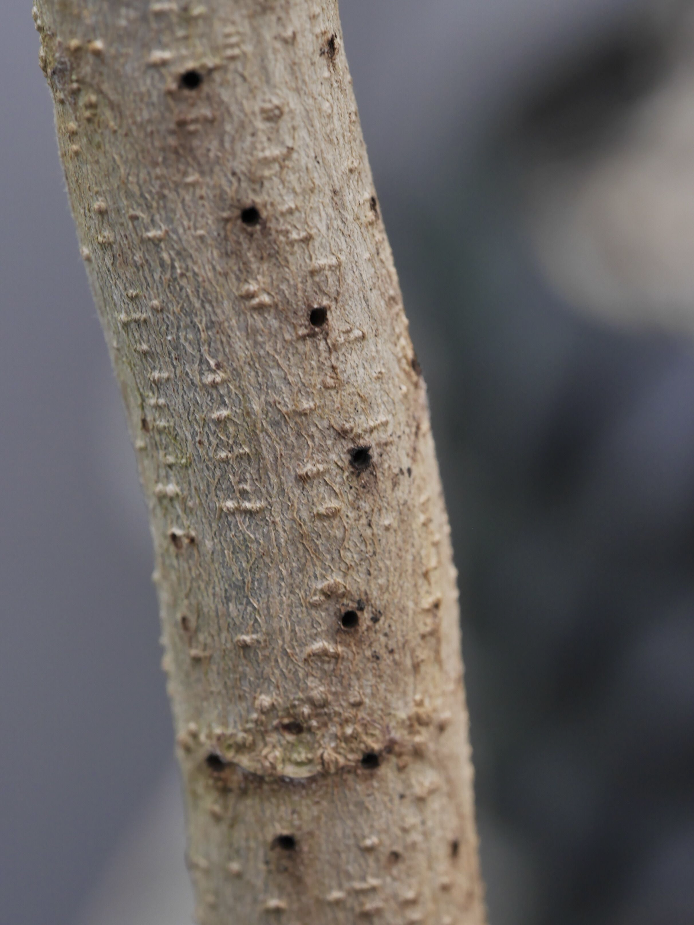

Figure 2. Xylosandrus compactus, black twig borer (Image courtesy of BugWood.org).